"Imagine you run 200 supermarkets across the UAE. Every day 102 products are being sold across every store. Some shelves go low. By the time a human notices, checks the budget, contacts the supplier, and places an order — the shelf is already empty. Today I am going to show you a system that compresses that entire process from days to minutes — autonomously."

Open the KPI dashboard. Do NOT open any dataset. Let the numbers speak:
Point to 79.5% availability — "1 in 5 shelves needs attention right now"
Point to 97 SKUs at risk — "97 different products have a problem somewhere"
Point to the pipeline feed — "The system has already been working. Let me show you what it decided."

Switch to HITL Dashboard (3 minutes)

======================================================
Before We Start — What is a Pipeline Object?

Think of the pipeline object as a shared notebook that all 4 agents pass between themselves. When Agent 1 finishes its analysis it writes its findings into this notebook and hands it to Agent 2. Agent 2 reads those findings, adds its own analysis, and hands it to Agent 3. And so on

Agent 1 — RCC Demand Intelligence Agent
Plain English — What is this agent's job?
This agent is the first responder. The moment a store's stock goes Critical, this agent wakes up automatically. Its job is to answer one question: how bad is this situation really?

It does not just look at one store. It looks at ALL stores carrying this SKU, checks if any big event is coming that would spike demand, calculates how much stock we are going to need, and works out whether standard ordering can even save us.

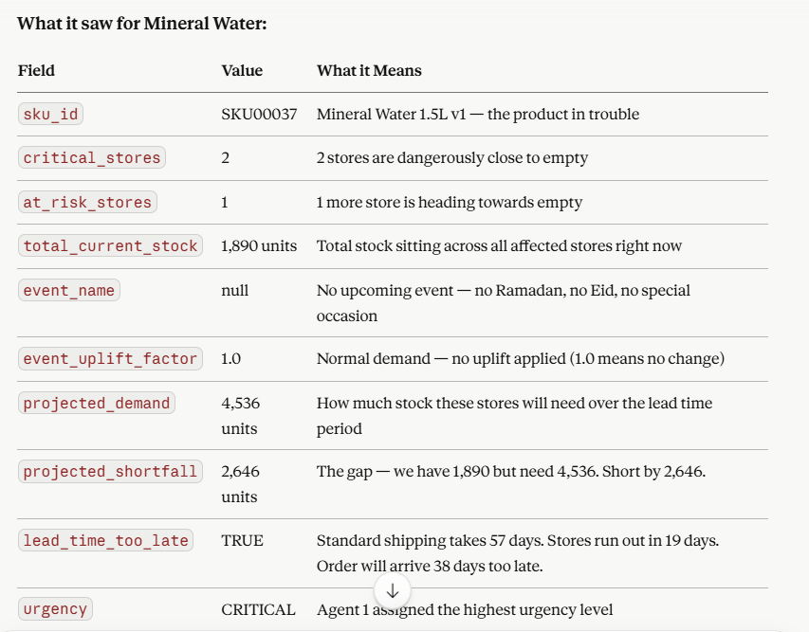

The key insight Agent 1 generated:
"Even without any event or seasonal spike — just normal summer demand — these stores will run out in 19 days. But our standard shipping from Gulf Beverages takes 57 days. We are already 38 days behind."
The lead_time_too_late = true flag is the most important output. It tells every downstream agent that standard shipping is not an option — we need to think differently.
Agent 1 then wrote all of this into the demand_summary field of the pipeline object and set pipeline_status = DEMAND_COMPLETE. That status change is what woke up Agent 2 automatically via the Automate chain.

Agent 2 — RCC Supply Replenishment Agent
Plain English — What is this agent's job?
Agent 2 is the options builder. It read Agent 1's findings — 2,646 unit shortfall, CRITICAL urgency, lead time already too late — and its job is to answer: what are our choices?
It always generates exactly 3 options. No more, no less. Each option represents a different commercial strategy with a different trade-off between cost, speed, and coverage.
What it built for Mineral Water:
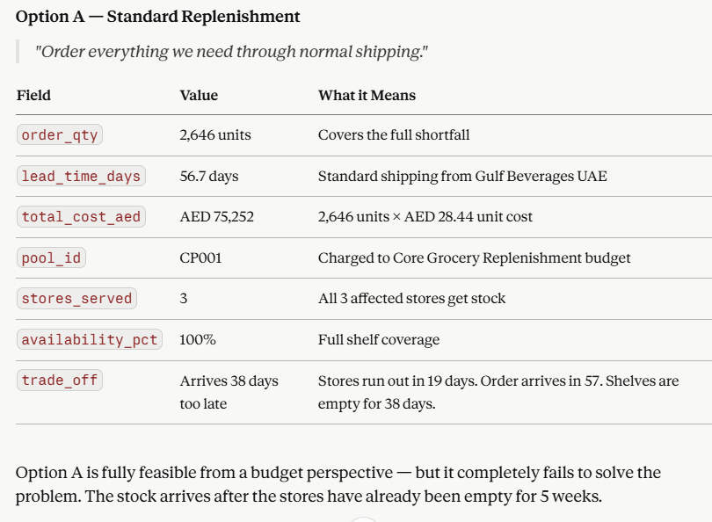

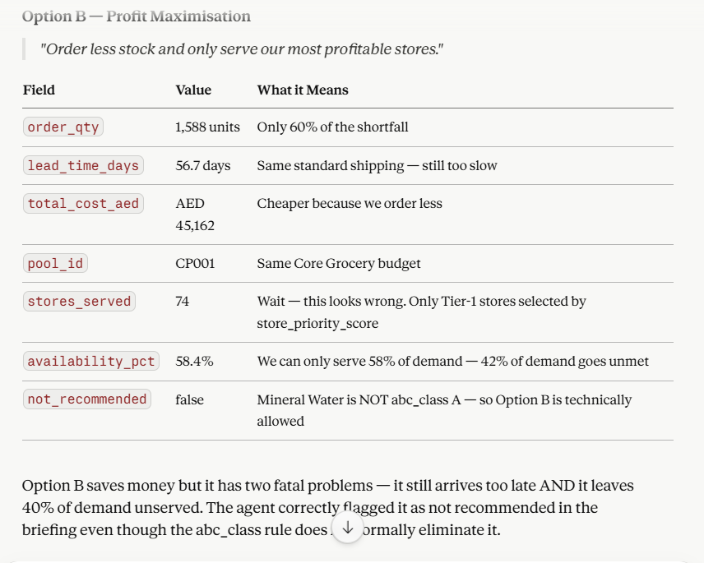

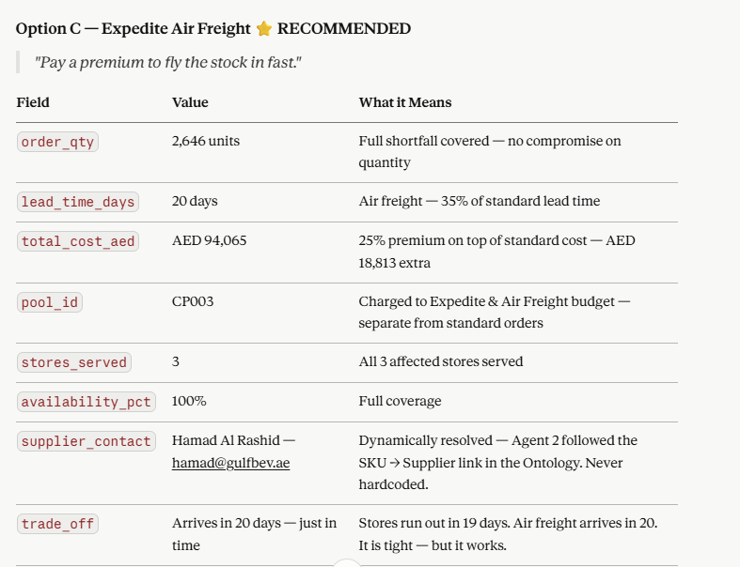

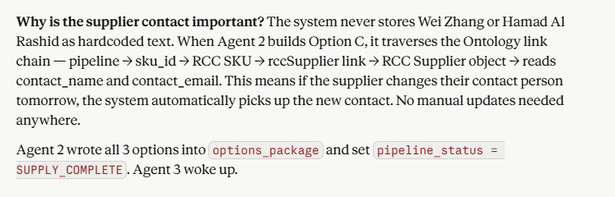

Agent 3 — RCC Capital Allocation Agent
Plain English — What is this agent's job?
Agent 3 is the financial referee. It has the 3 options from Agent 2. Now it needs to answer: which option should we actually choose, and can we afford it?
It does this through a scoring system — every feasible option gets a score out of 100. The highest score wins. But before scoring, it applies hard business rules that can eliminate options entirely.
The Scoring Formula — Explained Simply:
Think of it like scoring a job candidate on 3 criteria. Budget fit (how affordable is it?), Availability (how many shelves does it fill?), and Margin (how valuable is this product?). Each criterion contributes a maximum number of points to the total score.

Agent 3 — RCC Capital Allocation Agent
Plain English — What is this agent's job?
Agent 3 is the financial referee. It has the 3 options from Agent 2. Now it needs to answer: which option should we actually choose, and can we afford it?
It does this through a scoring system — every feasible option gets a score out of 100. The highest score wins. But before scoring, it applies hard business rules that can eliminate options entirely.
The Scoring Formula — Explained Simply:
Think of it like scoring a job candidate on 3 criteria. Budget fit (how affordable is it?), Availability (how many shelves does it fill?), and Margin (how valuable is this product?). Each criterion contributes a maximum number of points to the total score.
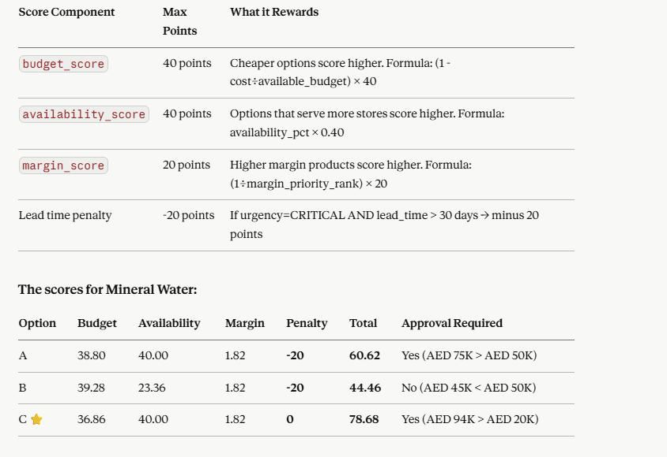

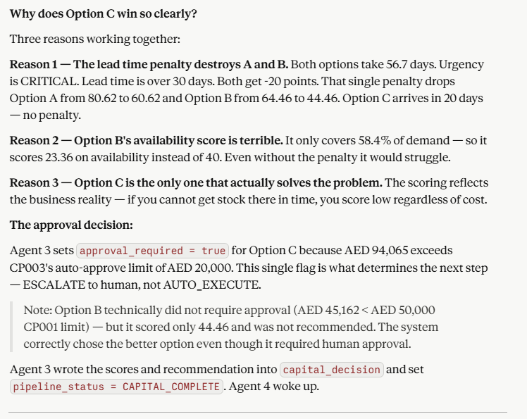

Agent 4 — RCC Exception Action Agent
Plain English — What is this agent's job?
Agent 4 is the decision gateway. It is the last agent in the chain. It reads everything the previous 3 agents produced and makes one final call: does a machine handle this, or does a human?
It routes every case through exactly one of 3 doors:

